|  |  |  |
| --- | --- | --- |
| SCHOOL OF INFORMATION AND TECHNOLOGY | | |
| NAME: Qaurte, Bryan Leonard F | DATE PERFORMED:12/09/24 |  |
| Section:IDC2 | DATE SUBMITTED:12/09/24 |

# SYSADM1 – Managing Services in Linux

# Requirement:

* A virtual machine running Linux

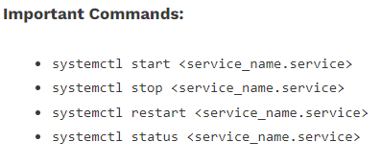

Complete this lab as follows:

Use the service –status-all command to list all active and inactive services.

List down active and inactive services in the table below. Provide five (5) services for each column.

|  |  |
| --- | --- |
| **Active** | **Inactive** |
| alsa-utils | bluetooth |
| anacron | console-setup.sh |
| apparmor | grub-common |
| apport | keyboard-setup |
| cron | plymouth |

SS: 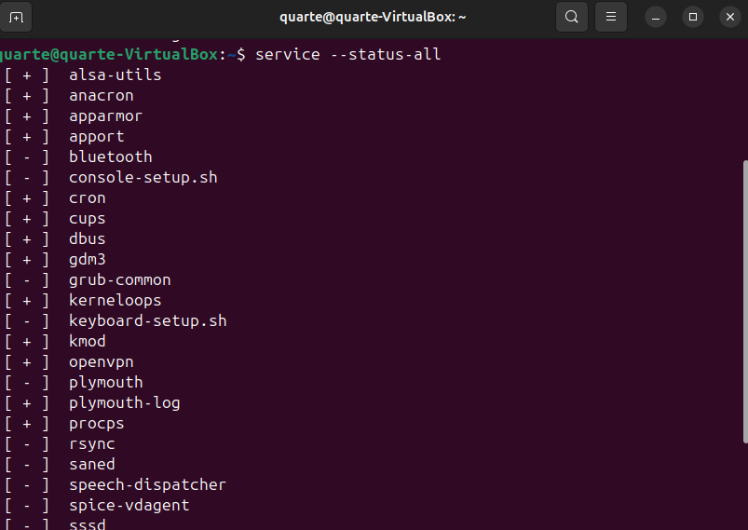

Start the Bluetooth service using the systemctl command.

Ex. sudo systemctl start httpd



Check the status of the Bluetooth service. What is its status? Still inactive

SS: 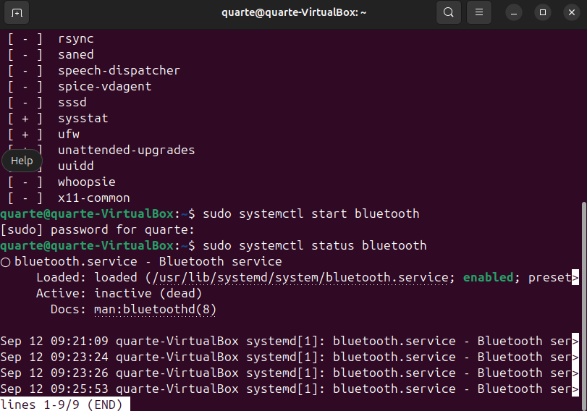

Check the status of the cups services. Since when was it running? 17 mins ago (Thu 1024-09-12 09:11:32)

SS: 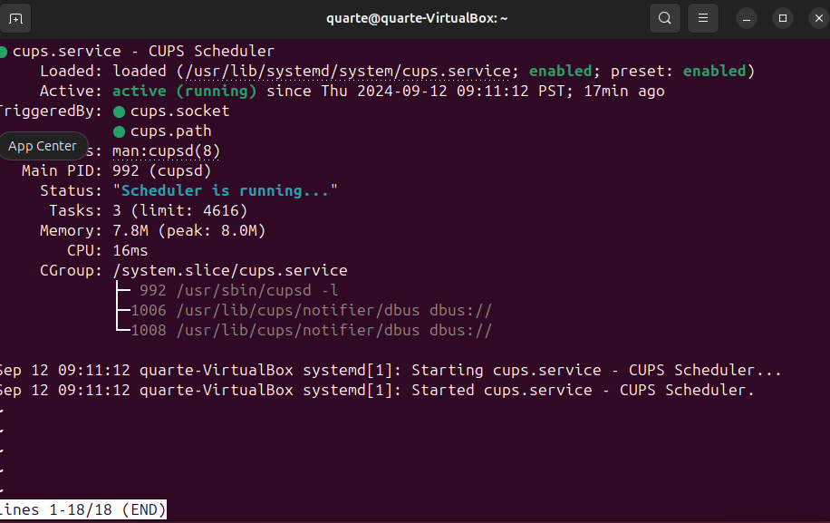

Stop cups services.

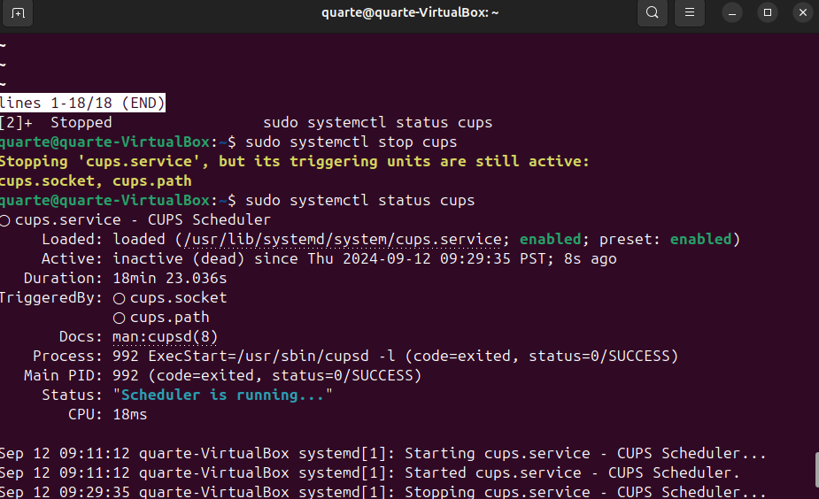

Verify if the service was stopped.

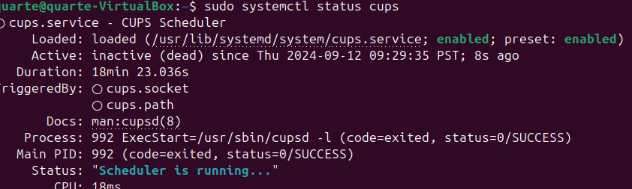

Restart the cups services

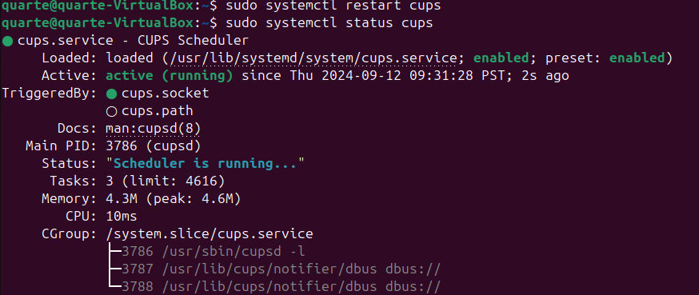

Verify if the service was restarted.

